Name- Arhan Gupta

Reg no. -20BCY10089

Email: arhan.gupta2020@vitbhopal.ac.in

**Assignment -2: Bash Shell Basics**

**Task 1: File and Directory Manipulation**

1. Create a directory called "my_directory".

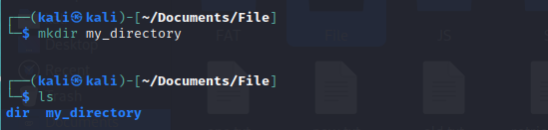

1. Navigate into the "my_directory".
2. Create an empty file called "my_file.txt".
3. List all the files and directories in the current directory.

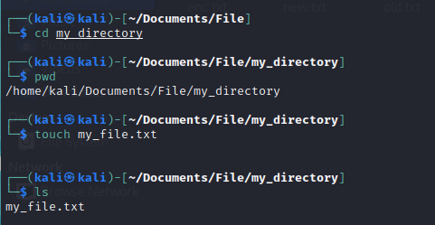

1. Rename "my_file.txt" to "new_file.txt".

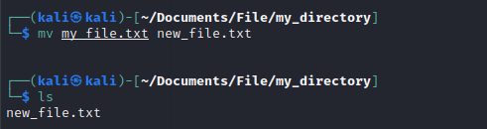

1. Display the content of "new_file.txt" using a pager tool of your choice.

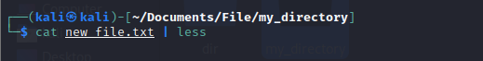

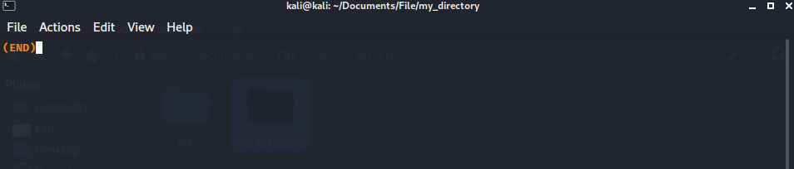

1. Append the text "Hello, World!" to "new_file.txt".



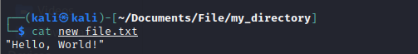

1. Create a new directory called "backup" within "my_directory".

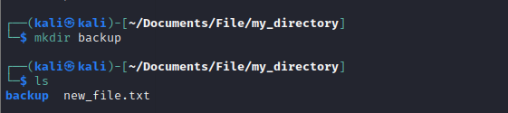

1. Move "new_file.txt" to the "backup" directory.
2. Verify that "new_file.txt" is now located in the "backup" directory.

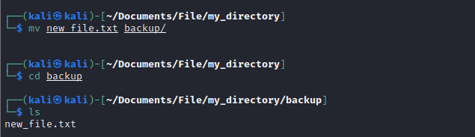

1. Delete the "backup" directory and all its contents.

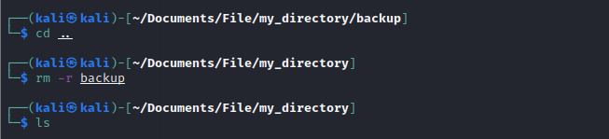

**Task 2: Permissions and Scripting**

* Create a new file called "my_script.sh".
* Edit "my_script.sh" using a text editor of your choice and add the following lines:

**bash**

**#!/bin/bash**

**echo "Welcome to my script!"**

**echo "Today's date is $(date)."**

**Save and exit the file.**

* Make "my_script.sh" executable.
* Run "my_script.sh" and verify that the output matches the expected result.



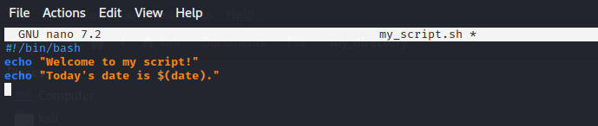

**STEPS**

Save and exit the file in the nano editor:

Press Ctrl+O to save the file.

Press Enter to confirm the filename.

Press Ctrl+X to exit the nano editor.

Make "my_script.sh" executable using the chmod command:

This command grants execute permission to the file.

Run "my_script.sh" using the ./ notation to execute it:

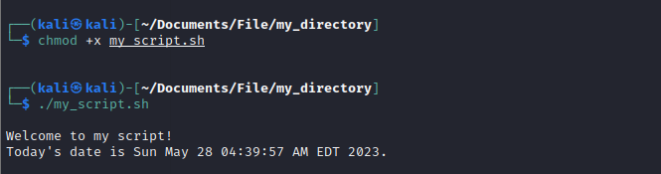

**Task 3: Command Execution and Pipelines**

* List all the processes running on your system using the "ps" command.

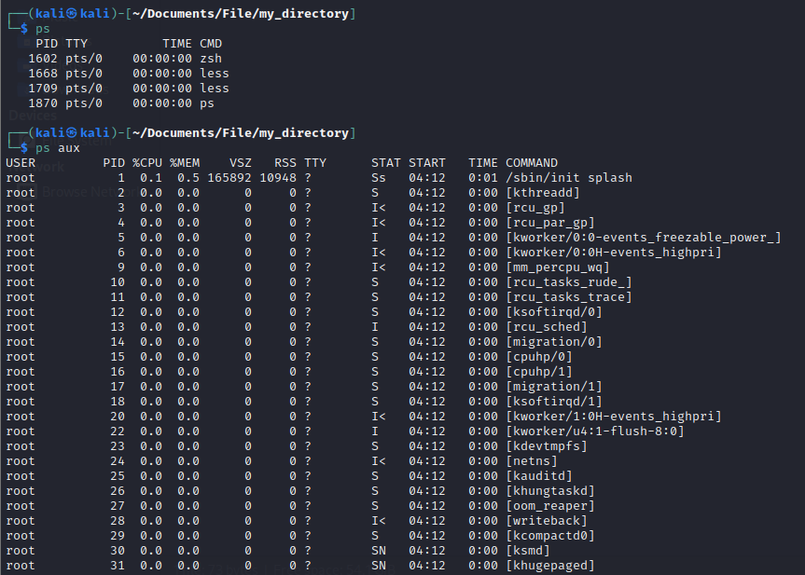

* Use the "grep" command to filter the processes list and display only the processes with "bash" in their name.

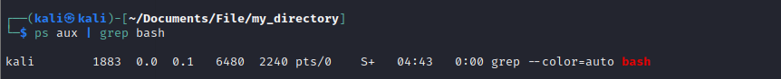

* Use the "wc" command to count the number of lines in the filtered output.

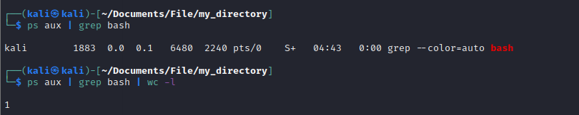

**Submission:**

Provide a document or text file containing the commands used to complete the tasks above, along with any relevant output or screenshots. Include your explanations or observations where necessary.